Minutes of a meeting of Halvergate Parish Council held at the Pavilion, Halvergate Playing, Wickhampton Road, Halvergate NR13 3BQ on Wednesday the 30th September at 6pm.
Present: Cllrs James (Chair), S Hannant (Vice Chair), C Hannant, Frosdick, Aspin & Green
In attendance: Philip Stone (Parish Clerk and Responsible Financial Officer)
District Cllr Nurden, County Cllr Thomas, Tom Cox Highways Engineer and two members of the public
- Apologies for absence
Cllr Reader proposed to accept; seconded; unanimously resolved.

- Declarations of Interest on matters on the agenda
None received.

- Cllr Co-option
The Chair introduced prospective Cllr Lisa Green. Proposed to co-opt Lisa Green to the position of Cllr, seconded unanimously, and resolved.

- Public Participation (max 10 minutes, any one person 3 minutes)
The members of the public present did not wish to make public comment or raise any concern.
To receive monthly reports from District and County Cllrs

Cllr Nurden: District Councillor Broadland Council Marshes Ward
- Ward budget availability of funds to local organisations; funding requests wanted.
- Cluster meeting reported on behalf of Halvergate re freedom of the Parish for community service, the success of Harefest and the installation of the new Trod.
- Non-payment of Precept addressed chased with Broadland and now paid.

Cllr Thomas: County Councillor for Acle Division
Cabinet Member: Chief Whip & Budget Responsibility (supported by written report)
- Local Government Reorganisation
No longer proceeding with elections for District Councils next May.
- Cabinet sets out new priorities
Strong emphasis on securing value for money for residents, improving performance and ensuring the authority remains focused on the services that matter most to Norfolk communities.
- 2027/28 Budget
Now a significant part of Cabinet workload. The financial pressures facing local government remain substantial, particularly across demand-led services such as adult social care, children's services and SEND, identifying savings; challenging costs, productivity, contracts, income opportunities and service performance to making sure the Council is obtaining the best possible value from the money it spends.
- Recycling centre survey
Norfolk County Council is seeking residents' views on its recycling centres as part of a review of the service. Looking to hear from people who do not currently use recycling centres as well as those who do, so that it can better understand how residents use the service and what barriers may exist. The survey remains open until 18 October 2026

- Approval of minutes 19th August 2026
Proposed to approve, seconded, unanimously resolved.
6. Matters arising from previous minutes:
Clerk update:
- Parish resilience plan
Contact made with a major Tunstall farmer who has confirmed willingness to assist in field area identification. Clerk requested to provide a populated plan for the next meeting.
- Overgrowth Branch Road
Tom Cox confirmed that flailing had been put on the work list and was due to be carried out.

- HGV on Branch Road
Issue relating to overweight vehicles ignoring Branch Roads weight restrictions and causing continuous damage to the road. The police have responsibility for enforcement of speed limits on this road; the clerk was asked to chase the police for a response as to how they propose to tackle the issue.

- Food waste caddies
Confirmed the District Council are taking action with the contractor Veolia to ensure the handling of the food caddies is improved.

- Hedge burial ground
Name of contractor obtained; awaiting quote and clarification of when the work can be carried out.
7. To confirm any delegated decisions
8. Updates and items for noting, review, discussion and resolution:
1. To note the bank reconciliation and to approve the monthly payment list.
RECONCILED BALANCE 21.09.26 £17,043.31 Noted.
SEPTEMBER MONTHLY PAYMENTS TO BE MADE
CLERK SALARY £538.59 (including back pay)
CLERK PENSION £178.11
TAX & NATIONAL INSURANCE £178.91
WFH ALLOWANCE £38.00
STAMPS £7.28
PAPER £9.80
STAPLER £3.99
LAND REGISTRY TITLE SEARCH £14.00
PKF EXTERNAL AUDITOR FEE £504
Proposed to approve the payment list, seconded, unanimously resolved.
2. Coronation bench shelter.
Cllr Frosdick confirmed the ongoing progress and that further works still remained to be done before installation can be considered. Council stated their gratitude to Cllr Frosdick for the quality of work and effort clearly visible in the work so far.
3. Remembrance Sunday.
In Cllr Reader's absence the Clerk was asked to clarify arrangements for the day with Cllr Reader and confirm to Council.
4. Pond and surrounding area Cllr S Hannant/ Clerk
Cllr S Hannant confirmed the desire to improve the pond area and to increase potential public access around it. The clerk confirmed the ownership of the area and that the owner had no objection to the council carrying out restorative works should they wish. The owner is not currently considering disposal of the area. Council confirmed at the current time they are not of a mind to carry out works to the area that they don’t own and questioned if it would be an appropriate use of public funds.
5. Trod
Tom Cox (Highways Engineer) confirmed the current situation in respect of the delivery of the trod and the problems encountered with roots to three trees within the conservation area, meaning the Trod has stopped 20 feet before Halvergate Hall and the potential options available.
- Continuation of the trod over the roots (not recommended).
- Retention of the bank by way of timber supports in the area and the introduction of a discretionary white line. (recommended).
6. Pillbox work
Ownership of Pillbox and location within the conservation area confirmed, clerk asked to liaise with owner re potential removal of overgrowth from Pillbox.
7. Allotments
The area has been cleared by Broadland Council, discussion in respect of the possible use of the area as a garden of reflection. Agreed should the council take on the land that it would require secure fencing.
8. Planning Call for sites for inclusion in the Greater Norwich 2045 Plan
Site details Site ID: 25780
District Broadland Parish Halvergate
Site address Land at Marsh Road and Tunstall Road, Halvergate. Area (hectares) 1.24 ha
Proposed use Housing, 10-49 units Greenfield site.
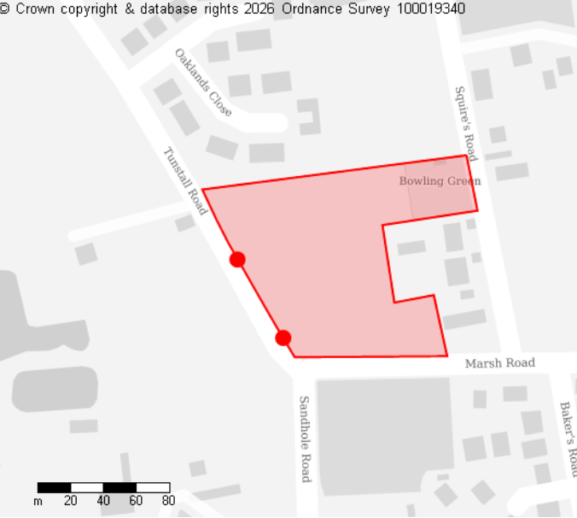
Councillors discussed the proposed inclusion of the aforementioned area of land as part of the call for sites for inclusion in the Greater Norwich 2045 Plan. It was noted that this will be available for Public Consultation in June/July 2027.
Ahead of this Public Consultation, Councillors wished to reassure parishioners of its position on this matter. Proposed that the Parish Council should reject the proposed development, seconded and unanimously resolved.

9. To note and confirm Clerk's National pay award of 3.3%.
Noted and confirmed. Clerks yearly employment review due in October.
10. Items for consideration for future Agendas.
None received.

Meeting closed 8.05 pm

