AGENDA Councillors are hereby summoned to attend a meeting of Halvergate Parish Council at the Pavilion, Halvergate Playing, Wickhampton Road, Halvergate NR13 3BQ on Wednesday the 12th November 2025 at 6pm.
Philip Stone
Philip Stone, Parish Clerk, 06.11. 2025 Tel 07519163895
1. Apologies for absence:
2. Declarations of Interest on matters on the agenda
3. Public Participation (max 10 minutes, any one person 3 minutes)
4. Reports from District, County, Parish Councillors and Saffron Housing
5. Approval of minutes of the Parish Council meeting of 1st October 2025
6. Matters arising from the previous minutes
7. Clerk Finance report: Account balance £82,852.88.
- To note additional funding secured from Lana Hempsall towards the trod.
- Funding secured for solar retro fit if required.
- Funding shelter opposite war memorial.
8. To confirm Delegated decisions: Clerk purchase of two wreaths Royal British Legion for memorial Sunday £50.
9. Items for discussion and resolution:
A) Approval of monthly payments.
B) To decide to proceed or not with retro fit of solar panels to Sam 2 Machines via Westco tec £1,200 plus vat (Funding secured from Lana Hempsall if required).
C) To consider the of restoration of shelter opposite war memorial total cost £3,050 council liability for £610.
D) Allotments to note reply from Broadland and the POLICE re no anti-social behaviour. To resolve to purchase or not.
E) Allotments if purchase agreed to allocate an initial sum of £10,000 from general reserves to earmarked reserves for future works.
F) To consider approval of NALC for monthly pay role, considering the added requirements for payment of national insurance above £5,000, monthly cost £12.
G) To review and confirm the sum of grant payable to the PCC for 2026/27 for grass cutting. Allowance of £1,800 included in the budget for 2026/27.
H) If required to review DRAFT budget agreed at last meeting with 3.02% precept increase in light of a decision on agenda item 9 G).
I) 1)To approve the appointment of an employment committee consisting of three members to deal with issues relating to employment and behaviour of members.
2) To decide if a meeting in December is required.
J) Planning
Ref 2025/2300
Proposal: Erection of a small garden building
Location: Horseshoe Barn The Street Halvergate Norfolk NR13 3AJ
Applicant: Mr Richard Moore https://info.southnorfolkandbroadland.gov.uk/onlineapplications/
applicationDetails.do?activeTab=summary&keyVal=T05FNXOQM7B00

Ref 2025/3194
Proposal: Erection of 1no self-build two storey dwelling, cart shed/store and all associated works.
Location: Paddock At Stables Tunstall Road Halvergate Norfolk
Applicant: Mr Thomas Carter
Application Type: Full Planning Permission
https://info.southnorfolkandbroadland.gov.uk/onlineapplications/applicationDetails.do?activeTab=summary&keyVal=T42HAZOQIAT00
K)Items for consideration for future Agendas
L) EXCLUSION OF PRESS AND PUBLIC To resolve, in accordance with Section 1(2) of the Public Bodies (Admission to Meetings) Act 1960 that the public be excluded from the meeting during the following item of business, as it is likely, in view of the nature of the business to be transacted or the nature of the proceedings, that if members of the public were present during this item there would be disclosure to them of exempt information within Paragraph 1 of Part 1 of Schedule 12A to the Local Government Act 1972. report. REASON - Confidential Business – to consider the exclusion of the press and public for the following item on the grounds that information about an individual member of staff is confidential between the council and the staff member. Under the Data Protection Act, a council also has obligations as to how it uses such information about an individual
To formally review clerks’ performance in accordance with the job evaluation matrix and consider implementation of its minimum or above recommended rate of pay.

PUBLIC INFORMATION PACK
5. Approval of minutes of the Parish Council meeting of 1st October 2025
Minutes of a meeting of Halvergate Parish Council held at the QEII Pavilion, Playing field, Pavilion Wickhampton Road, Halvergate NR13 3BQ on Wednesday the 1ST October 2025 at 6pm.
Present: Cllrs James (Chair) S Hannant, C Hannant, Reader, Collins, Frosdick
In attendance: Philip Stone (Parish Clerk), District Cllr Nurden.
Minutes taken by the Parish Clerk
1. Apologies for absence: Cllr More (Vice Chair) proposed to accept, seconded, unanimously resolved.
2. Declarations of Interest on matters on the agenda: None received.
3. To receive reports from: a) Tom Cox, (Highways) concerning:
Maintenance Branch Road
• Proposed to recommend the road for a full scheme of repair in 2026, if approved work to take place 2027.
• Highway Barriers, Branch Road to be inspected and appropriate works to be recommended for scheduled repair.
• TROD Wickhampton Road, scheduling of works delayed until agreement reached by the District Council tree officer as to which retained trees require permission for work to commence.
• Officer Cox agreed to investigate maintenance of the road over the railway bridge, particularly the bump on the Halvergate side.
b) Officer Pritty Broadland & South Norfolk Council.
Allotment acquisition.
• Permission granted for disposal to the Parish Council at no cost. PC will have to meet its own legal costs.
• There will be a covenant in the sale deed that the use of the land must have benefit to the community in respect of its use, such as community orchard, allotments, open space.
• The Chair confirmed the PC would discuss the matter and confirm their decision to Broadland & South Norfolk.
4. Public Participation (max 10 minutes, any one person 3 minutes) None present.
5. Reports from District and County Councillors
District Cllr Nurden:
• Pleased to see the installation of the new doors installed at the Halvergate sports Pavilion with the aid of the District Cllr allowance.
• Broadland District Council have submitted their recommendation to the government for 3 Unity Councils for Norfolk as opposed to Norfolk County Councils recommendation for one.
• Community grant scheme now closed, oversubscribed.
5. Approval of minutes of the Parish Council meeting of 20th August 2025
Proposed to approve, seconded, unanimously resolved.
6. Matters arising from the previous minutes
Noted although no report received from the County Cllr, Cllr Nurden had shared a report from the County Council detailing their monthly activity.
7. Clerk Finance report: Current account balance
a) Bank balance £96,719.50. Details re placing funds on deposit with the district Council provided for consideration.
8. Cllr Reports
9. Items for discussion and resolution:
a) Burial ground works. (Cllr S Hannant) date awaited from the contractor for commencement of works.
c) Approval of monthly payments. Proposed to add to payment list Harefest grant payment of £1,000. Seconded, unanimously resolved. Proposed to approve payment list of £13,189.82 seconded, unanimously resolved.
PAYMENTS
TROD PC contribution £11,254.83
Income tax £110.60
Norfolk Pension Fund £131.82
Clerk Salary £443.05
WFH & Internet allowance £44.00
NPTS membership £179.77
Sundries Ink £25.00
Bank Charges £6.75
Harefest Grant £1,000

TOTAL £13.195.82
e) Remembrance Sunday arrangements (Cllr Reader) arrangements in hand Cllr Reader will liaise with the clerk re the road closures.
f) To note and agree NALC, clerk contractual pay award 3.2%. proposed to note and confirm, seconded, unanimously resolved.
g) To consider clerks, performance and current pay Scale including award as per item 8 f) £16.90 per Scale 20. No review given, request received from clerk to increase pay to the sum of £17.85 from £16.90.
g) Draft budget 26/27. General discussion around the budget concern raised by Cllr Hannant in respect of the size of the grant to the PCC, suggesting consideration should be given to reducing the figure as a direct result of the Church being able to fund the grass cutting from their share of the sale proceeds of the Village Hall. Proposed Cllr Frosdick to approve draft budget increase of 3.2% increase, subject to agreement in respect of clerks pay and the sum of grant payable to the PCC for grass cutting. Seconded Cllr James, unanimously resolved.
Meeting closed 8.20 pm

7. Clerk Finance report: Account balance £82,852.88.
- To note additional funding secured from County Cllr Lana Hempsall towards the trod.
- Funding secured for solar retro fit if required.
- Funding shelter opposite war memorial.

Restoration of bus stop opposite war memorial total cost £3,050 PC contribution 20% £610.
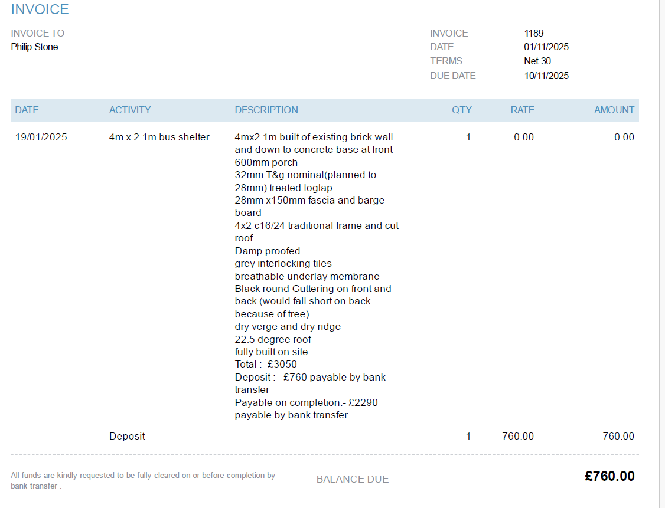
Hi Philip,

I’ve amended the figures and the NCC contribution is now £2,440.

9. Items for discussion and resolution:
A) Approval of monthly payments.
HALVERGATE
Monthly Payment List NOV 25
- Clerk Salary £443.05
- WFH & Internet allowance £38.00
- Norfolk Pension Fund £131.82
- Income Tax £110.60
- Bank Service Charge £6.25
- Poppy Appeal £50.00

Total £779.72

Optional payments
JLG Carpentry deposit £760.00
Total price £3,050
Funding secured Norfolk County Council 80%
£2,440, sum payable by council £610

D) Allotments to note reply from Broadland and the POLICE re no anti-social behaviour. To resolve to purchase or not.
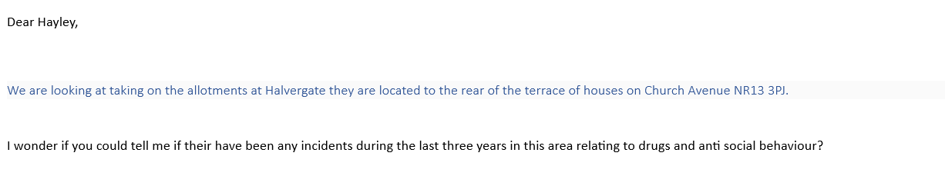
Police rep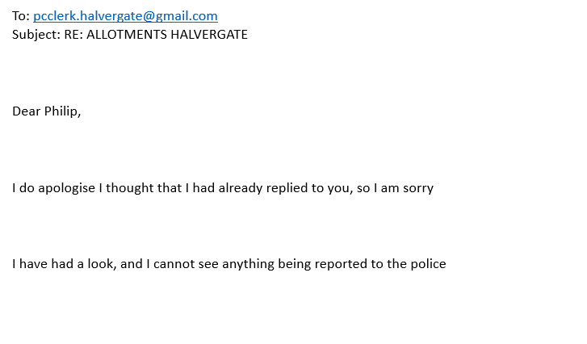
Reply from Broadland
