PUBLIC INFORMATION PACK 20.08.25
AGENDA Councillors are hereby summoned to attend a meeting of Halvergate Parish Council at the Pavilion, Halvergate Playing, Wickhampton Road, Halvergate NR13 3BQ on Wednesday the 20th August at 6pm.
Philip Stone
Philip Stone, Parish Clerk, 14 .08.2025 Tel 07519163895
1. Apologies for absence:
2. Declarations of Interest on matters on the agenda:
3. Public Participation (max 10 minutes, any one person 3 minutes)
4. Reports from District and County Councillors
5. Approval of minutes of the Parish Council meeting of 9th July 2025
6. Matters arising from the previous minutes
7. Clerk report:
a) Bank balance
b) Tree report
c) Trod
d) Allotments
8. Cllr Reports
9. Items for discussion and resolution:
a) Burial ground works. (Cllr S Hannant)
b) Arrangements for internments/ burials. (Cllr S Hannant)
c) Approval of monthly payments.
d) Additional trod works.
e) Telephone box Halvergate (Cllr Collins)
f) Mental Health Training
5. Approval of minutes of the Parish Council meeting of 9th July 2025
Minutes of a meeting of Halvergate & Tunstall Parish Council held at the Pavilion, Halvergate Playing, Wickhampton Road, Halvergate NR13 3BQ on Wednesday the 9th July at 6pm.
Present: Cllrs James (Chair), Reader, Collins, Frosdick, S Hannant, C Hannant
In attendance: Parish Clerk Philip Stone, District Cllr Nurden. No members of the public.
1. Apologies for absence: None received.
2. Declarations of Interest on matters on the agenda: Cllr Reader item 8 a) member of the HPCC.
3. Public Participation (max 10 minutes, any one person 3 minutes) N/A
4. Reports from District and County Councillors Cllr Nurden:
- Community awards now open.
- Town and Parish Forum. Cllrs encouraged to attend.
- Norfolk community high street grant initiative open.
- Ward grant budget now allocated to include application from the playing field towards new doors.
5. Approval of minutes of the Parish Council meeting of 28th May 2025. Proposed to approve, seconded, unanimously resolved.
6. Matters arising from the previous minutes: Verge Marsh Road
- Ditch clearance during nesting season and responsibility. The clerk confirmed the clearance was the responsibility of the drainage board and that the work that had been carried out had been done without authorisation and has been acknowledged by the drainage board.
7. Clerk report:
- Tree report received and circulated, recommend sending a copy to District Council tree officer, Halvergate Hall, HPCC, Playing field committee.
- Branch Road dip chased with Highways.
- Bleed kit registration referred to supplier, for registration with the appropriate authorities.
- Sale of the village hall completed. Contractual payments made to the PCC to cover 30% of the net proceeds and contribution of £700 towards survey fees.
- Cost of £2,000 plus vat saved as a result of the clerk acting as the appropriate officer of the council and conducting the conveyancing on sale.
- 7. (a) Bank account balance as at 07.07.2025 £119,966.83.
- b) Pot hole update Branch Road. Chased with NCC highways.
- c) Trod, issue raised by the Safety Team at NCC, await their confirmation before being able to proceed.
8. Items for discussion and resolution:
a) Ratification of authorisation for sale of village hall given in between meetings to Parish Clerk. Proposed to ratify decision to authorise Parish Clerk to sell the Village Hall for £100,000. Proposed, seconded, unanimously resolved.
b) Allotments, consideration given to the benefits of acquiring the allotments and their ongoing administration. Proposed to confirm to BDC that the parish council wish to acquire the allotments with the aim of clearing the site and redeveloping it into allotments and or a community orchard, seconded, unanimously resolved. Clerk to confirm to Broadland Council.
c) Burial ground works. Postponed to next agenda.
d) To decide on necessary action following receipt of tree report. Proposed clerk to send a copy to District Council tree officer, Halvergate Hall, HPCC and the Playing field committee.
e) Approval of monthly payments. The clerk confirmed that the sum of £700 contractually due to HPCC following completion of the sale of the village hall had still to be paid and that as a result of a slight overpayment made on completion that the sum of £695.98 was due to be paid rather than £700.
ACCOUNT BALANCE 07.07.2025 £119,968.83
- PHILIP STONE LEGAL DISBURSEMENTS RFUND SALE VILLAGE HALL £67.00
- LEGAL ID COSTS CLLRS MORE AND JAMES £25 EACH £50.00
- PHILIP STONE REINBURSEMENT AGAR PRINTING & SCANNING £30.00
- PHILIP STONE INK CARTIDGES X 2 £30.00
- PHILIP STONE CLERK SALARY £420.02
- HMRC TAX £104.80
- CLERK PENSION £155.85
- CLERK WFH, PHONE AND INTERNET ALLOWANCE £44.00
- FARMLAND FORESTRY TREE REPORT £480.00
- HPCC 30% OF NET PROCEEDS OF SALE OF VILLAGE HALL £29,468.70
- HPCC SURVEY COST CONTRIBUTION £695.98

TOTAL £31,521.35
Proposed to approve, seconded and resolved. (5 in favour 1 against.)
Cllr Frosdick stated he was unhappy with the figures paid to the HPCC and in his opinion the £700 had been paid twice. He went on to make inappropriate statements towards the clerk inferring financial impropriety and to each Cllr in turn suggesting they all had individual conflicts of interest in respect of the sale of the Village Hall and the only person that was impartial was himself. The Chair and the clerk advised Cllr Frosdick that his conduct and statements were inappropriate to the council’s code of conduct and advised the procedure for reporting such issues to the monitoring officer at the District Council.
MEETING CLOSED 7.50 PM
Philip Stone Issued: 14.07.25
Philip Stone Parish Clerk pcclerk.halvergate@gmail.com Tel: 07519163895

6. Matters arising from the previous minutes
1.Verge Marsh Road reply from drainage board awaited.
2. Branch Road dip repaired.
3. trod revised plan and costings received.
7. Clerk report: ,
a) Bank balance
Bank statement: Statement 29th July 25 £88,918.73
b) Tree report
Copied to Playing field for their action as they consider appropriate.
c) Trod
Dear Sirs,
I understand this project trod Halvergate has been added to therefore I do now need to make payment of an additional sum to you, but to date I have not been informed how much you require if you could please confirm and I will make immediate payment.

TOM COX is fully aware of the extent of the development.
d) Allotments
11.0825 update

Hi Philip,

As stands I don’t have an update for you, so I wouldn’t have much to provide at the meeting. I have written the report to be presented to the portfolio holder and I am waiting for my line manager to provide feedback / confirm a date for this. Once we have the portfolio holder’s acceptance, we can move to agreeing precise terms and instructing the disposal. We can’t take it too far anyway until the licenses expire on the 30th September.

Kind regards,
Aaron

Aaron Pritty
Community Assets Management Officer

9. Items for discussion and resolution
c) Approval of monthly payments.
- PHILIP STONE CLERK SALARY £420.02
- HMRC TAX £104.80
- CLERK PENSION £155.85
- CLERK WFH, PHONE AND INTERNET ALLOWANCE £44.00

TOTAL £724.67
d) Additional trod works.
24.07.25
Good evening Phillip,

The design is attached.
Total cost comes to £44,509.67.
It is just over twice the length of the previous distance, so there are some savings for undertaking the work in one hit.

That is guaranteed maximum cost, I would hope it will be delivered lower than that but can't guarantee it.

Let me know when you have a decision.

Kind regards, Tom

Tom Cox - Highway Engineer North 4

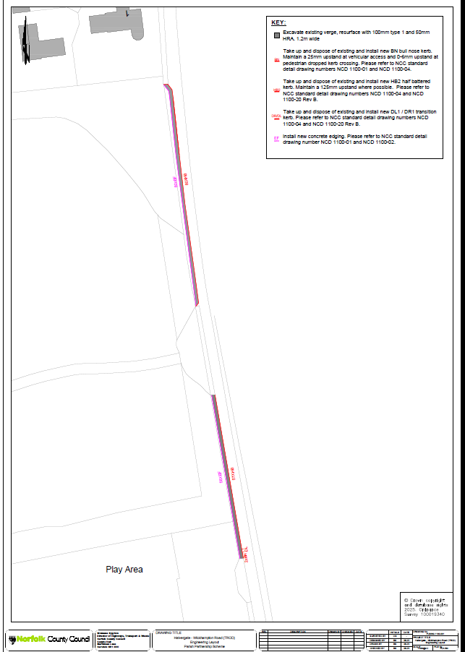

30.07.25
Dear Tom,

Council have confirmed yes to the full project please confirm full figure required to be paid by us and I will get payment made thank you for your assistance.

Kind regards

PHILIP STONE
Parish Clerk
Halvergate
14.08.25
Dear Tom,

I have a meeting next Wednesday and I would like to make payment for any further monies required for the complete project if you could confirm the sum required. Please also confirm current arrangements in respect of the tree work.

If you get a minute a quick call would be helpful thanks tel 07519163895.

Kind regards

PHILIP
Parish Clerk
14.08.25 (Credit control Norfolk County Council)

Dear Sirs,
I understand this project trod Halvergate has been added to therefore I do now need to make payment of an additional sum to you, but to date I have not been informed how much you require if you could please confirm and I will make immediate payment.

TOM COX is fully aware of the extent of the development.

Kind regards

PHILIP STONE
Parish Clerk
Tel 07519163895

REPLY TOM COX

I am out of the office on annual leave, returning on the 26th of August. I will respond as soon as possible upon my return.
In the event of an emergency please contact highways@norfolk.gov.uk.

e) Telephoe box Halvergate (Cllr Collins)
14.08.25
Dear Philip

Thank you for your mail,

Just to bring you up to speed, there have been some changes to our team over the past 6 months or so, I am sad to say that Linda Kennedy passed away earlier this year and Mandy Greenslade has retired and in enjoying the quiet life.

I believe this is the kiosk you are referring to...
Kiosk Number: 01493700411
Kiosk Address: Pco1 The Street Halvergate Norwich, NR13 3AJ
Kiosk Type: Listed K6
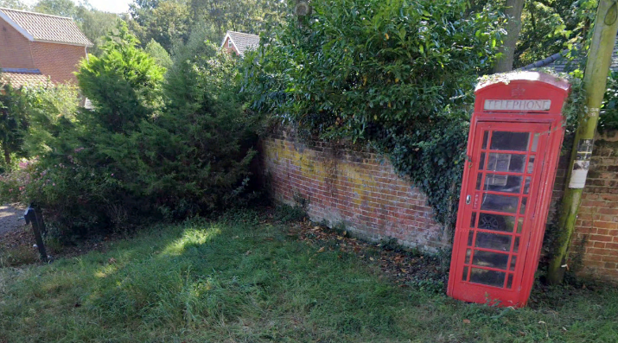

We can confirm that this particular kiosk is NOT a candidate for payphone service removal at this time.

We at BT payphones are continuing with our street rationalisation project to remove some of the payphone estate as it is no longer financially viable to run, but we are constrained by the OFCOM Universal Service Obligation which states that if the call box is considered to be “Last at Site” (more than 400 metres’ walking distance from the next public call box), there are 4 criteria that need to be adhered to before we can proceed with removing the telephone mechanism:
- There must be full mobile coverage from all 4 of the main UK operators (Three, EE, O2 and Vodaphone)
- The kiosk in question must have had less than 52 calls made within a 12-month period.
- It’s not in a protected location (i.e. accident blackspot / high-frequency suicide location)
- No other evidence of reasonable user need.

Kiosk Number: 01493700411 is considered to be “Last at Site” and the mobile coverage at the kiosk is deemed to be inadequate to allow removal.

Please see the following link, you may find this of some interest:
Protecting essential phone boxes - Ofcom

I hope this helps,

Many thanks,

Roxanne Krefta
BT Networks - Payphones

f) Mental Health Training (Cllr James)

Improve mental health awareness for your community

South Norfolk and Broadland District Councils are working with the Norfolk and Suffolk Foundation Trust's Wellbeing Service, Thriving Workplaces and Evolve to make South Norfolk and Broadland more 'Mindful Districts' through our Mindful Towns and Villages project.

South Norfolk and Broadland Councils are offering community groups and small businesses free mental health training to raise mental health awareness in the community and empower people to start a conversation and have the tools to signpost people on to local services, including the Councils’ Help Hub. The training will enable people to recognise mental health issues and supply low-level support to individuals in their community.

Your area can achieve 'Mindful Town & Village' status, with the tools to develop a community-led network of Wellbeing Champions. To be recognised as a mindful place, several representatives from your local community can join the network through either completing any of the training courses below or sending a relevant certificate for training already completed. Wellbeing Champions could be members from sports clubs, pubs, small local businesses, community organisations, the Town Council, or any other local community pillars. When individuals have completed the training, they will receive window stickers to make residents aware where they can seek support. These can be displayed to show that the place is a safe place to talk and has a Wellbeing Champion for support.

The next training dates are below and more will be posted on our website soon – to become a South Norfolk and Broadland Wellbeing Champion, you can do any of the courses.
- 13 September 6.45-8.45pm - Dussindale Centre, Pound Lane, Thorpe St Andrew, NR7 0SR. Wellbeing Champion Training, sign up by 10 September 2023

- 28 September 6.30-8.30pm - Diamond Jubilee Lodge, Hellesdon, NR6 5QB. Mental Health Awareness in the Community, sign up by 24 September 2023

- 18 October 9-4.30pm - Barnard Suite, Bawburgh Golf Club, Glen Lodge, Marlingford Road, Bawburgh, NR9 3LU. Mental Health First Aid Champion Training, sign up by 10 October 2023

- 26 October 2.00-4.00pm - Tibenham Community Hall, Pristow Green Lane, Tibenham, NR16 1PX. Wellbeing Champion Training, sign up by 23 October 2023

If you would like to find out more information on the project, the training course content or to sign up, please visit our webpage at https://www.southnorfolkandbroadland.gov.uk/communities/mindful-towns-villages or scan the QR code. Alternatively contact the team on communities@southnorfolkandbroadland.gov.uk 01603 430611.

