HALVERGATE PARISH ANNUAL OPEN MEETING
DRAFT Minutes of the Annual Open Meeting held at the Playing Field Pavilion on Thursday 18th May 2023 at 630 pm.

Present : Cllrs, Robert More Vice Chair Parish Council, Steve James,Stuart Hannant, Carol Hannant, Philip Williams, Billy Frosdick

In attendance : Parish Clerk Philip Stone, Grant Nurden (District Councillor) 15 Parishioners

(In the absence of the Chair of the Parish Council the Vice Chair Robert More chaired the meeting)

- Apologies for absence:
Charles Reader (Chairmen Parish Council ) work commitments.

- Adoption of minutes of the Annual Parish meeting held on 12th May 2022:
The Minutes of the Annual Parish Open Meeting held on 12th May 2022 were accepted as a true and accurate record, proposed, seconded, unanimously resolved. The minutes were signed and dated

- Matters arising from the minutes
Proposed Youth Club being arranged by Lucy Horton, the chair confirmed unfortunately she had now left the village and that no one can be found to take on the proposed club, the chairman made an open request to the meeting for this to be taken on, no one came forward.

- CHAIRMAN’S REPORT
I would firstly like to apologize for not being able to give this speech in person this year – unfortunately an unavoidable work commitment, taking me away from home for several weeks, was imposed on me some time before the date of this meeting could be fixed.

Firstly, this year has seen changes to the parish council itself. In the summer we said goodbye to Jess Jennings, who had served as Clerk to the Parish council since 2012. Jess is now very well-established as an advisor to students applying for university courses, and is still Parish clerk to Beighton PC. We were sorry to see her move on from Halvergate, but are very grateful for the 10 years of loyal service she put in to the post.

Her place has been taken by Philip Stone, whom we warmly welcomed as our new Clerk in October. Philip hails from Gorleston and has brought with him a wealth of experience borne of many years dealing with local government at various levels. As chairman I feel very confident in the advice that Philip is able to provide, and I can bear witness to the huge energy he brings to the post – whose duties are often rather more complicated and onerous than many people realize.

We also have to say goodbye to Michael Mallett and to Tom Carter, both who have served for 40 years or more as councillors. Michael was a stalwart of the Village Hall and Social Club, and with his late wife Lorraine he provided much of the impetus for the maintenance of the village hall. He also has a huge knowledge of the history of the village, which has often been very useful when making decisions at council level.

Tom Carter though originally from Brundall, has also lived in Halvergate for many years, and many of his relations were Halvergate people. He has always been a clam and steady presence on the council meetings. He has also been a hard worker in keeping areas of the village, particularly around the war memorial and bus shelter, clean and tidy. It is all too easy to forget that these places only look respectable because of the hard work that people like Tom put in.

I would also like to thank the Vice Chairman, Robert More, who is also a great source of useful advice on how to proceed with council matters – again based on much experience of committees of various kinds locally and further afield. There have been many times when O would not have known how to proceed without his insights.

Carol Hannant is another councillor of long-standing, whose dedication to the village is very obvious to all who know her and in particular her devotion to the Playing field means that this great asset to our village continues to provide a place of recreation to people of all ages.

Stuart Hannant is a keen supporter of the village, and has overcome infirmity brought on by illness some years ago with determination and resolve – and conversations with him show that he is very keen to ensure that our little community has a vibrant future.

Steve James is another councillor who has experience of local government, and his quiet wisdom has come to bear many times since he first joined us as councillor. So I am delighted that he has put himself forward for the post of Chairman of this council, a post I have held myself for 8 years, but now feel ready to pass on. I have every confidence in him as a successor.
We also welcome Philip Williams and Billy Frosdick as newly appointed councillors. Both have taken a keen interest in the Parish Council for several years, having both regularly attended PC meetings in the past. As mentioned, Philip has already brought his IT skills to bear in extracting important data from our SAM machines.

WHAT HAS BEEN GOING ON (In no particular order)
A few years ago, the Parish Council invested a considerable sum of money in a SAM (Speed Awareness Machine), and this proved so popular with villagers that it was decided to invest in a second machine, and this became operational a few months ago, so that we now have two machines that we can move about to different locations. The rather tedious job of collecting, collating and distributing the data regarding the speeds at which vehicles have been driven through the village was firstly carried out very effectively by Stuart Simpson since we first acquired the machine. He eventually had to relinquish this task – and we are very grateful to him for having carried it out so effectively. He handed over to Sean and Su McKnight, who also lent a valuable hand, and now Philip Williams has stepped up to the plate. All have provided a very valuable service. We will never stop lunatics driving through the village a ridiculous speeds, but at least more sensible drivers are reminded to lift their foot off the pedal, which can only be a good thing.

As a council we have been particularly active recently to improve the road infrastructure within the parish area, and three ‘pinch-points’ are notable in this regard. The first is the stretch of Wickampton Road that lies between the entrance to Halvergate Hall and the junction of the road with Bakers Rd and The Street. It has long been the case that this stretch has been getting narrower and narrower as the vegetation along the hedge on the Hall side has encroached, such that nearly three feet of tarmac is now lying under what has become the verge. This presents a serious danger to people, especially small children, walking along the road from the village to the playing field.

The second is the appalling state of the metal railing between the road and the Fleet Dyke on Marsh Road. This length of railing has nearly fallen into the dyke, so that not only does it look very unsightly, more seriously it is serving no safety function at all in its present condition.

We has also been seeking consultation on the matter of the lack of viable footpath along the stretch of Tunstall Road, where it meets Sandhole Corner.

There have been ongoing attempts to get some interest at District or County level in the dangerous state of the Branch Rd. Older parishioners may remember that this road became badly buckled in the long dry summer of 1976. Nothing significant has been done about it since.

The Parish council has almost no executive power in these instances – all public roads are ultimately the responsibility of Highways, who are often very slow to respond at all. However, site meetings have been held, and we hope that our perseverance in these cases will soon be rewarded with action, at least in part.

Much of the village lies within the Halvergate Conservation Area, which imposes restrictions both on development and tree-felling in order that the village should not use its essential character. For this reason, we have noted the importance of the roof of Stone Cottage being repaired in a manner in keeping with the overall age and appearance of the house, and representations have been made to the DC in that regard. Similarly, we have contacted BDC about the continued presence of scaffolding around Halvergate Mill. Like Stone Cottage, the Mill is a Grade II listed building and one that lends much character to the extreme southern end of the village, and we will continue to monitor those two properties. Furthermore, a poplar tree at the front of the Red Lion was illegally topped, and then the work was presented pretty much as a fait accompli to the licensee, Jayne Pitchers, in such a way as to leave her powerless to prevent it – this was duly reported, but, so far as we know, no action has yet been taken.

The future of the Village Hall, which is currently held in trust by the Parish Council on behalf of the village, has recently been a subject of much discussion within Council meetings, given that the Village Hall committee, the body charged with running of the hall, has now been wound up, and that responsibility for this has now reverted back to the Parish Council. This is not a responsibility that the Council itself is in a position to take on, and therefore some decision will need to be taken in due course as to how to proceed. It is worth pointing out that the hall was formally church property, and was sold to the Parish Council in the 1970s for the nominal sum of £5 (so that in practical terms it was gifted), on the condition (in the form of a restrictive covenant) that the hall could only be used as a village hall. In other words, the PC cannot simply elect to put the hall on the market in order to raise funds for the village. That is all we can say at this stage, though discussions are ongoing in order to find a legally binding solution as to what to do with the hall – and the community as a whole will of course be consulted before any final decision is made

In the course of WW2 three Allied warplanes were lost in separate incidents in the marshes below the village. Following an approach by a villager whose father had been able to offer comfort to one of the airmen as he lay dying from his injuries, the PC agreed that it was high time that some kind of memorial should be erected in the village to commemorate the sacrifice of the 17 young men who died in these three crashes. Memorials of this kind to be found in nearby villages such as Reedham, Ashby and Rackheath, villages which were all scenes of similar tragedies. I am delighted to say that this project is now proceeding apace, and we plan to unveil this monument in the presence of distinguished guests on Thursday July 6. Details of this ceremony will be announced very shortly.

Earlier this year the PC listened to a presentation given by the Saffron Housing Trust, a housing association part of whose function is to provide affordable housing on suitable land in communities where such a need has been identified. Parishioners may remember receiving a questionnaire several months ago designed to find out if there was such a need within Halvergate, either amongst young people seeking to get on the housing ladder, or amongst the elderly who might be looking for appropriate housing enabling them to stay within the village, or both. If such needs become apparent, the land which for some time has been fenced off between The Avenue and Gillett’s Drive has been identified as a potential site for 15 dwellings. This investigation is ongoing, and no formal plans have yet been submitted. If and when this project becomes more concrete, a village meeting will be called to scrutinise and discuss it fully.

Finally, as I step down as from the post as Chairman of the PC I would say that the 8 years in the role have taught me that even in this small community, with an electorate barely 400-strong, there will always be a wide range of opinions as to what the future of our village should be. Yet in listening to these varied opinions, it is clear to me that we are all nevertheless united in our desire to ensure that Halvergate and Tunstall continue to be such precious and rewarding places in which to live.

Financial Report (Given by Clerk and questions raised replied to)
On Following page

Question from a parishioner, what are salaries?, clerk confirmed salaries as shown are for the clerk in position for that year.

Question from Cllr Williams, what is Misc? confirmed as per the cash-book breakdown already provided to councillors details of which will be published on the website in due course.

Question from a parishioner, insurance for the village hall can this not come from the closing balance received from village hall funds? Confirmed the funds from the village hall were being used for ongoing costs of the council and the village hall which include the insurance costs applicable to the Village hall.

- Correspondence Directed to the Meeting
None received

- District Councillor report Grant Nurden
Broadland District Council Annual Report – Marshes Ward
What a year it has been, we have come out of Covid, we have seen the tragic invasion of Ukraine and the impact on the world energy crisis, and very sadly we also saw the loss of our beloved majesty Queen Elizabeth II.

Without fear of contradiction, once again Broadland District Council through the One Team has more than risen to the occasion and has had a year packed full of delivery, be that in social infrastructure, physical infrastructure or environmental infrastructure. Across the range of services that the Council delivers, it has been extremely busy with no sign of respite. From the purchase of the Horizon Building, to the completion of the Broadland Food Innovation Centre, from the roll out of the food waste collection service to every household in the district, to the launch of the single finance system, we have delivered on multiple fronts.
With the office-based staff now all working from Thorpe Lodge or home, the place has a real buzz about it with lots of good conversations happening about issues facing all our residents.
The Council, together with South Norfolk District Council, had a first joint Peer Review which gave us lots to build on with the Review Team highlighting many of the great things that we do and telling us to shout about our successes a bit more. They highlighted just how far the Councils have come since we embarked on the collaborative working arrangement over 4 years ago.

We have continued to develop our relationships with Towns and Parishes, particularly through the regular Forum meetings held online with Members and Clerks and look forward to growing this further over the coming years.
Looking ahead, there is more than a bit going on. The Council will be moving into our new shared headquarters at the Horizon Centre, expected to be ready by the end of April / early May. The collaboration continues to reduce individual and collective revenue requirements year on year, creating the capacity to be able to support those in our community that need it and support our businesses to survive and grow through uncertain times. We also expect to see the resolution of Nutrient Neutrality and the normalisation of the planning process.
I would like to extend my thanks to the Clerk and the Parish Council for your support and assistance in resolving our community’s issues over the past year.
Cllr Grant Nurden District Councillor

- County Councillor report Lana Hempsall
It was noted by members of the council that the District Councillor was not in attendance for the second year at the Annual meeting and that no apologies or written report had been received by the clerk.

- Organisation reports received

Halvergate Playing Field Association Annual Report 2022-2023
Verbal report received.

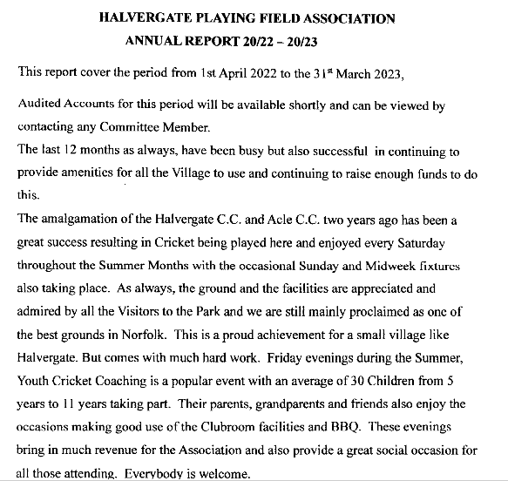

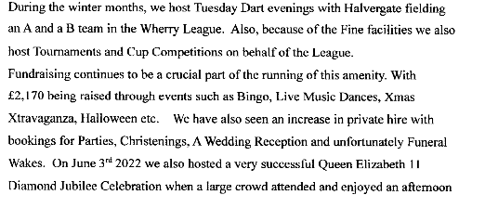

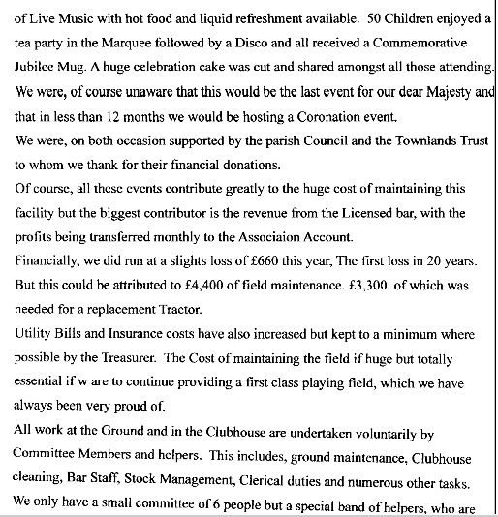
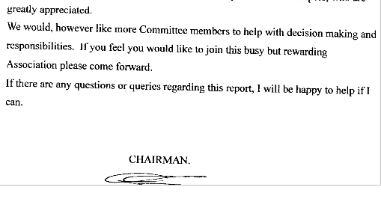

TOWNLANDS TRUST
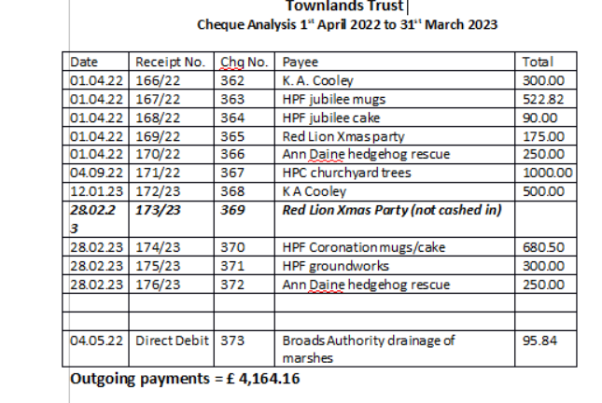
Gratitude was expressed by parishioners for the continuing assistance given by the Townlands Trust to the Village.

- Parishioners Open Forum
Parishioner confirmed the first responders will be back up and running soon, and that the defibrillator at the Playing field had recently been used.

Parishioner raised concern in respect of the state of the road surface to Squires Road, including flooding. Parishioner will liaise direct with the PC Clerk who will the parishioners concern to the County Council.

Parishioner raised concern in respect of the roads coming in and out of the village not being cleared and narrowing, suggested by the chair that the PC need to undertake a survey of all the roads and the work required before submitting to the county council a view supported by Cllr Hannant.

Parishioner raised concern in respect of a cherry picker that has been parked near the post box causing damage to the verge, issue being actively dealt with and chased by Cllr Carol Hannant. Apology received from the chair who confirmed it was a contractor working on his land that had caused the issue, the chair will make good the damage occasioned.

Parishioner raised concern in respect of the tyre tracks on the memorial green, caused by BT Open Reach, clerk asked to write to Open Reach asking that they do not park on the Green. Clerk confirmed the ruts caused by open reach had been dealt with and filled in.

Cllr Carol Hannant asked what is the position in respect of the Village hall. Clerk confirmed the council had discussed the matter and had written to the PCC re the removal of the restrictive covenant and that a formal response was still awaited. Clerk further confirmed that the matter would be featuring on future council agendas and once a decision re the halls future had been made a public meeting would be held so public opinion could be confirmed before proceeding further.

Meeting closed 7.30pm

Philip Stone Parish Clerk pcclerk.halvergate@gmail.com
Tel: 07519163895

