HALVERGATE PARISH COUNCIL
Minutes of a meeting of Halvergate Parish Council held at the QEII Playing Field pavilion on Wednesday 24th January 2024 at 6 pm.

Present: Councillors: S Hannant, C Hannant, Frosdick, Reader, James (Chair)

In attendance: Parish Clerk P Stone
District Councillor Nurden
1 member of the public

Members of the public and the press are welcome to attend. Should you wish to ask a question or highlight an issue or comment on anything on the agenda please contact the clerk at pcclerk.halvergate@gmail.com

AGENDA
The Chair welcomed members of the public and District Councillor Nurden.

Apologies for absence received and accepted:

County Councillor Lana Hempsall (conflicting meetings)

Councillor More (previous engagement)

- To receive declarations of interest on matters on the agenda.
Cllr Reader item 6 a Church wall (as a member of the PCC)

Chair statement: Cllr James
a. Confirmed he had received the formal resignation of Cllr Williams on the afternoon of 24th January.

To adjourn the Meeting to allow for:
Proposed, seconded, adjourned

  - Public Participation: An opportunity for the public to address the council 10 minutes.
No matters raised

  - County Councillor Report Lana Hempsall (5 minutes).
(No report received)
The clerk confirmed that he had spoken to County Councillor Hempsall and requested her help and assistance with funding for the remedial drainage works required for the burial ground and that she had confirmed she would do all she could do to assist.

  - District Councillor Report Grant Nurden (5 minutes).
Confirmed the availability of current grants:

The Cleanup and Bloom grant, the Energy grant scheme and the Keep it going grant.

Next cluster meeting to be at Halvergate.

To approve the Minutes of the last Parish Council Meeting of 13th December 2023

Proposed, seconded, unanimously resolved.

- Clerk report matters to note and arising from previous minutes
Including:

  - Burial ground consecrated areas.
The clerk confirmed with Cllr S Hannant that he had met with the vicar and the unconsecrated area had been confirmed as the area past the blue stick. (Any internment in this area the ground receives a blessing before internment.)

  - Village gateways. Cllr Frosdick
Proposed to be fully discussed at the next meeting, seconded unanimously resolved.

  - Website.
The issue with website access has been resolved and the page updated.

  - Councillor conduct.
Councillors were reminded that they are bound by the adopted code of conduct and are expected to behave according to it.

  - Pride in Place clean-up & Bloom grant.
The grant became available via Broadland and South Norfolk District Council since the last council meeting with a short window of availability, an application was made by the clerk on behalf of the council and approved with the council being awarded £300 towards wildflower seed for the burial ground. The clerk confirmed receipt of the grant funds.

- Items for Discussion and Resolution
  - Church wall (Cllr James)
Cllr James, confirmed he had received correspondence from the PCC (Parochial Church Council for Halvergate) confirming they were undertaking a full structural assessment of the wall and asking if the PC could contribute towards the cost? The PC debated the issue but felt they were unable to contribute.

  - Halvergate Day (Cllr James)
Cllr James explained his vision for a yearly day of celebration to celebrate the village, bringing the community together. The suggestion was very well received. Cllr James will liaise with the clerk and the Recreation Ground Committee and report back at the next meeting. (It was proposed, seconded and unanimously confirmed that Halvergate Day will be an ongoing agenda item for the immediate future.)

  - Flooding burial ground recommended remedial works (Cllr S Hannant)
Cllr Hannant gave a full report on the issues being experienced relating to surface water flooding caused by lack of drainage at the burial ground with some graves being partially under water following a downpour. Cllr S Hannant put forward three potential remedies all of which were debated with the second option being the preferred course of action in the first instance. The council agreed the situation was unacceptable for relatives and would need to be dealt with as a priority. Proposed by Cllr James that the clerk would attempt to obtain quotes for the proposed works and funding asap and if funding was not forthcoming council would look to fund the work from reserves, seconded, unanimously resolved.

  - Highways/ road remedial work.
The council acknowledged issues with highways within the parish, and the clerk confirmed he was liaising with highways and awaited a visit from the highways engineer so the works required could be prioritised.

  - Tree warden.
The council acknowledged the importance of having a dedicated warden, proposed the position was taken by Cllr Frosdick, seconded, and unanimously resolved. The clerk will liaise with the District Council and arrange for appropriate training to take place.

  - Meeting dates August.
The council felt the August meeting date was required and that it should not be removed for a summer recess. Proposed, seconded, unanimously resolved.

Finance

Approval of monthly payment sheet.

Proposed:

To agree the reconciled balance of £17,401.85 as at 12.01.2024.

To note receipts of £300.

To authorise payments totaling £953.

To note after the deduction of monthly payments the current account balance of £16,748.85.

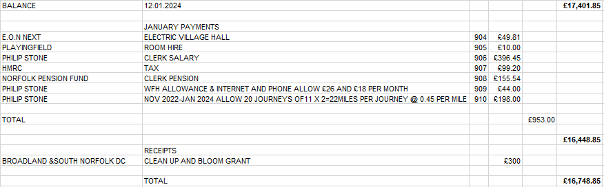

Seconded, unanimously resolved

- Planning
  - Replacement of existing single-storey rear extensions with two-storey side/rear
extension with balcony to rear.
Location: 1 Bakers Road Halvergate Norfolk NR13 3PY
Applicant: Mr And Mrs Taylor
Link:
info.southnorfolkandbroadland.gov.uk/online-applications/applicationDetails.do?activeTab=summary&keyVal=S592HYOQ0PY00

Proposed no objection, seconded, unanimously resolved.

b. Application Number : 2024/0055
App Type : Works to trees in Conservation Area
Parish : Halvergate
Location : Dalmahoy Marsh Road Halvergate Norfolk NR13 3QB
Proposal : G1 Elder and Sycamore -dismantle to ground level. T2 Ash -
dismantle to ground level. T3 Whitebeam (approx 7m in height and
7m wide) reduce crown by 1-1.5m. T4 Acer -re-pollard at 3-4m

Proposed, no objection, seconded, unanimously resolved.

- To consider excluding the public under the Public Bodies (Admissions to Meetings) Act 1960, to exclude the public due to the confidential nature of the item to be discussed.

Council considered for openness and transparency that exclusion of the public was not required

  - Village Hall report (Cllr James)
Cllr James confirmed valuations had now been received by PCC and the PC, he proposed that the valuers liaise to agree a valuation before proceeding further, (clerk to facilitate) he also recommended that the question of selling the Hall should be resolved by parishioners at the annual general parish meeting, seconded, unanimously resolved.

Meeting closed 7.54pm

Philip Stone (Parish Clerk)
Issued 11.02.2024

